**A Level Drama and Theatre studies**

**What will I need to study this course?**

You need at least a grade 4 in GCSE English. It's helpful if you have studied GCSE Drama, but it's not necessary.

**What will I study?**

* Component 1: Theatre Workshop

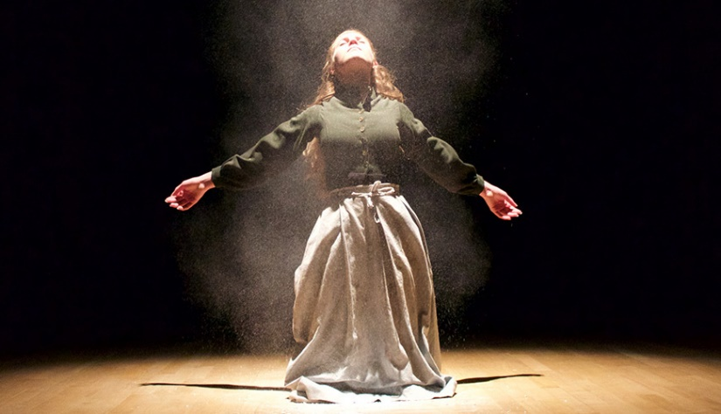You'll re-imagine a text in the style of a chosen theatre practitioner.

* Component 2: Text in Action

You will create two performances. One is a piece you make up from a prompt given by Eduqas, and the other is from a text you choose. Both performances will be influenced by a theatre practitioner you choose.

* Component 3: Text in Performance

This is a written exam. You will study and explore the plays 'Cat on a Hot Tin Roof' by Tennessee Williams and 'Saved' by Edward Bond, and apart from 'The Curious Incident of the Dog in the Night-Time'. You'll learn about acting, directing, and being an audience member. 

**How is the course assessed?**

Unit 1: Assessed by your performance and coursework, marked by your tutor.

Unit 2: Performance exam, marked by an external examiner.

Unit 3: Written exam paper.

This is a written exam. You will study and explore the plays 'Cat on a Hot Tin Roof' by Tennessee Williams and 'Saved' by Edward Bond, and apart from 'The Curious Incident of the Dog in the Night-Time'. You'll learn about acting, directing, and being an audience member.

**Where next?**

This course can lead to studying Drama, Theatre Studies, and Performing Arts at university. It can also help you in careers in the Performing Arts industry. The skills you learn can complement other subjects and are useful for building confidence and improving presentation skills for various careers.

[What can I do with a degree in drama? | Prospects.ac.uk](https://www.prospects.ac.uk/careers-advice/what-can-i-do-with-my-degree/drama)

*Exam Board: Eduqas*

*QAN Code: A690QS*