Eduqas A Level Music

What will I need to study this course?
This course is great for students who love playing and creating music alongside learning about the history of Music. To join, you need to have a grade 5 or higher in GCSE Music and be at grade 4 or above in your main instrument or singing.
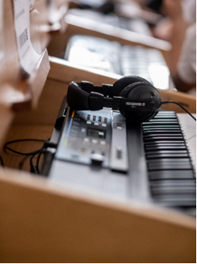
What will I study?
Component 1 – Performance - Choose for this to count towards 25% or 35% of your overall grade:

25% - You will perform a minimum of 2 pieces as either a solo or part of an ensemble. Your performance will last for between 6 and 8 minutes.

35% - You will perform a minimum of 3 pieces as either a solo or part of an ensemble. Your performance will last for between 8 and 10 minutes.

The expected level of performance is Grade 6, however grade 5 will be accepted, as will pieces higher than grade 6 standard. Your final performance is to a visiting examiner.

Component 2 – Composition - Choose for this to count towards 25% or 35% of your overall grade:

25% - You will create two compositions lasting between 4 and 6 minutes in total. One is a free composition and the second is to a brief set by the exam board.

35% - You will create three compositions lasting between 8 and 10 minutes in total. One is a free composition, the second is to a brief set by the exam board and the third must be in one of the following styles: Jazz, Musical Theatre, Rock and Pop, Into the 20th Century or Into the 21st century.

Component 3 – Appraising – 40% of the overall grade – 2hr15mins exam

You will learn about the following areas of study:

Area Of Study A – Western Classical Tradition – With a detailed study of the following pieces: Haydn | Symphony 100 and Schubert | Symphony 5.

A choice from:
Area Of Study B – Rock and Pop
Area of Study C – Musical Theatre
Area of Study D – Jazz

A choice from:
Area of Study E – Into the 20th Century – With a detailed study of the following pieces: Poulenc | Trio for Oboe, Bassoon and Piano | Movement I and Debussy | Three Nocturnes | Number 2 Fetes
Area of Study F – Into the 21st Century – With a detailed study of the following pieces: Errolyn Wallen | Concerto Grosso | Movement 2 and Mark Anthony-Turnage | Frieze | Movement 4

Within these areas you will learn about composers, how music is created and what techniques are used.

How is the course assessed?
Your grades will come from 40% exams and 60% non-exam tasks.
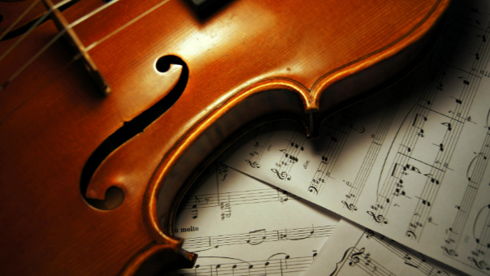
Where next?
This course can help you get into university programs in Music, Performing Arts, Music Industry Management, or Arts Management. It can also be useful for other types of courses, apprenticeships, or jobs.

What can I do with a music degree? | Prospects.ac.uk
Exam Board: Edexcel
QAN Code: 601/7090/6

