A Level Mathematics

What will I need to study this course?
To study this course, you usually need to have achieved a GCSE grade 6 in Mathematics, specifically from the Higher Tier paper.

What will I study?
In this course, two thirds of the focus is on Pure Mathematics.
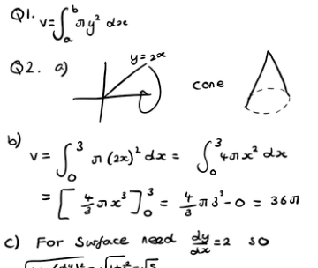
- You'll build on the algebra and trigonometry you studied at GCSE.
- You will explore new concepts like calculus, vectors, exponentials, and logarithms.
- Calculus deals with continuous change, while vectors are used in 3D space, such as in computer graphics.

The remaining third of the course is about Applied Mathematics, and is split equally between Statistics and Mechanics.
- Statistics involves analyzing data, learning about probability distributions like binomial and normal distributions, and hypothesis testing.
- Mechanics covers forces and motion, including Newton’s Laws, kinematics, momentum, friction, and projectiles.

How is the course assessed?
The entire course is assessed through exams. At the end of Year 13, there will be three 2-hour exams. There are no coursework requirements.

Where next?
A Mathematics A-Level is highly respected and beneficial for careers in business, IT, science, engineering, psychology, accountancy, and more. It also supports studies in other A-level subjects that use mathematical concepts, such as sciences and psychology.

What can I do with a mathematics degree? | Prospects.ac.uk

Exam Board: AQA
QAN Code: 603/1164/2

