**Fakenham Sixth Form Rewards & Behaviour**

Introduction

1.1 At Fakenham Sixth Form we are committed to providing an outstanding learning environment leading to strong educational outcomes and healthy life opportunities. Exemplary behaviour is at the heart of productive learning.

1.2 A priority is to ensure that all teachers deliver Quality First Teaching, where teaching is of high quality, inclusive, with barriers considered and planned for. All members of our school community have the right to learn, teach and work without disruptions and feel safe, with mutual respect prevailing for all.

1.3 Central to this policy are our academy values, ‘Kindness, Ambition, and Determination’. Students will be encouraged and rewarded when they:

Are KIND, so they are settled for learning and feel safe.

Are AMBITIOUS by knowing their targets and taking up opportunities available.

Are DETERMINED by working hard and showing resilience when faced with challenges.

1.4 At Fakenham Sixth Form, we believe that implementing this behaviour policy consistently and fairly is the responsibility of all members of the Academy Community.

Rewards

Fakenham Sixth Form puts an emphasis on recognising and reinforcing behaviour that consistently meets our high standards. This is in line with our Core Values of Kindness, Ambition and Determination.

Recognition of kindness, Ambition and Determination will be recorded on ClassCharts, for which students will receive ‘positive merits’. Students who go above and beyond will be recognised by a Positive Note which is worth 5 Merits. <https://www.classcharts.com/>

Students will also receive a positive note for 96% or higher attendance every half term.

Students will receive verbal praise alongside these merits.

Students will be rewarded for the following:

|  |  |  |  |
| --- | --- | --- | --- |
|  | **Kindness** | **Ambition** | **Determination** |
| Examples | * Helping someone * Caring for the environment * Charity work * Volunteering in Fakenham Academy * Volunteering outside of Fakenham Sixth Form | * Independent study * Super curricular activity (an activity that build on subject specific content) * Extracurricular activity (e.g. Sixth Form club, revision session) * Leadership/student voice. * Representing Sixth Form. * Meeting or exceeding target grades. | * Working hard * Persistent punctuality * Overcoming difficult situations * Not giving up * Improving grades in assessments. * Lesson engagement |

Students will be able to convert merits into prizes at the end of every half term.

|  |  |
| --- | --- |
| **Points** | **Prize** |
| 75 | This is the starting threshold to select a reward from our rewards box. Students can pick one item at a time at a rewards assembly at the end of term.  They will then select items every 50 merits after this. |
| Items |  |
| The highest 5-10% Depending on the size of the cohort) at the end of school year. | Amazon voucher |

Students will also receive postcards home, phone calls and rewards assemblies once a term.

Ratio 90

To further celebrate the success of our students we will run a Ratio 90 programme. For students who have a ratio of 90% of positive to negative behaviours we will run one trip a term. Examples of these events could be Christmas shopping in Norwich, Bowling, Summer BBQ.

Behaviour

Negative behaviours will be recorded on ClassCharts using the same C2 area used in the Academy.

* C2-failure to wear the correct uniform would be issued if a Sixth form Student fails to wear their lanyard or is dressed inappropriately.

Students who receive five negatives in a term, will receive a Sixth Form Support session for 15 minutes, at lunch time, with Mrs Marshall-Smith. This will be based on an academic mentoring conversation

As previously mentioned, if students receive a low positive ratio (under 90%) they will not be able to attend the rewards events.

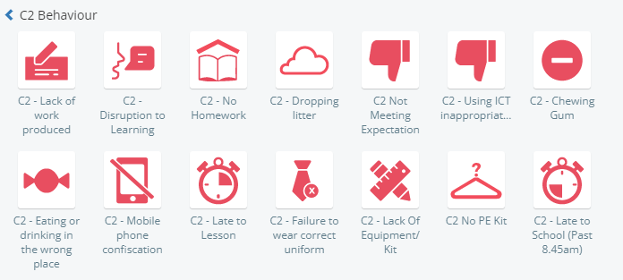

C3.

* If a student is disruptive during your lesson or fails to follow instructions, staff can give them a C3 and ask them to leave the lesson and complete work in the study room.
* If this happens staff will need to add a C3 withdrawn.
* Please add a detailed explanation as to why the student was asked to leave and contact home.
* A C3 will lead to a further meeting with the form tutor.