Fakenham Sixth form Attendance Policy For Students and Parents

Attendance at sixth form matters because it has a direct impact on students' academic success, personal development, and prospects. When students attend regularly, they are more likely to develop a deeper understanding of subject matter and develop essential critical thinking skills. Attending sixth form regularly allows students to develop vital life skills, such as time management, self-discipline, and responsibility. These skills will serve them well in their future academic and professional pursuits, where they will need to balance multiple responsibilities and manage their time effectively.

Fakenham Sixth Form monitors student attendance to ALL timetabled lessons and study periods. In the case of Staff absences, Students are expected to complete work on site in the Sixth Form Study Room; attendance will be recorded in these cases.

The government defines good attendance as 97% or higher. Anything below 90% is considered a persistent absence. If a student is persistently absent, then parents will be invited in to discuss any issues.

The table below shows how many hours of learning are missed when a student is absent.

* Each day of school absence means missing a minimum of 5 hours of learning, including crucial content for exams and coursework.
* There are only 360 hours of guided learning for each A Level/BTEC so missing the odd day really adds up!
* Sixth Form students are expected to attend school every day.

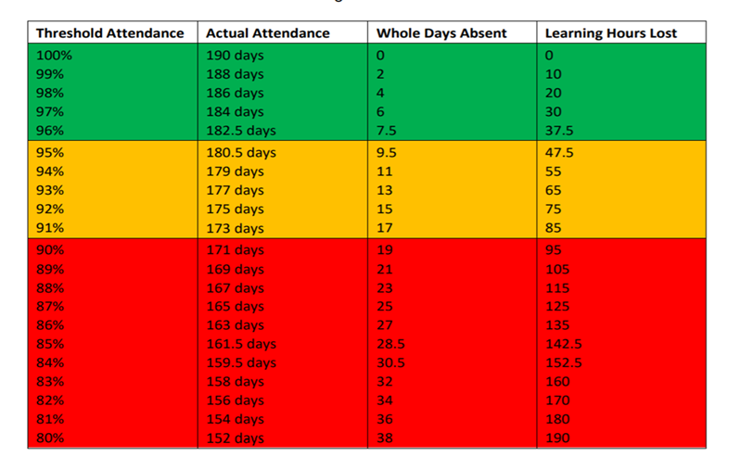

**Reporting Absence**

Parent/Carer Responsibility

If your child is absent, due to illness, it is important that you contact us before 8:30am on the first day of absence, and on the morning of every day of absence thereafter.

You can report an absence the following way:

Email [office@fakenhamacademy.org](mailto:office@fakenhamacademy.org)

Expressions app

Telephone: 01328 862545 (Press Attendance Option)

If your child has a medical appointment, we ask that you inform us prior to the appointment, where possible.

If a student has not registered in the morning, a text message will be sent to parents/carers. Parents/carers can reply to this message or alternatively contact the above number and leave a message.

### 

### Leave of Absence Requests

It is the student and/or parents' responsibility to inform the Sixth Form Office, in advance, if they will not be in on a particular day or for a particular lesson. Failure to do so will result in an unauthorised absence and, if applicable, bursary funding could be stopped.

Examples of absences which may be authorised in advance are:

* A medical appointment which cannot be made out of academy time (Evidence Required).
* A religious holiday.
* Attendance at a funeral.
* A driving test (practical or theory test) but NOT driving lessons.
* A University interview or open day (evidence required).

Students must complete the leave of absence form for any planned absence. <https://forms.office.com/Pages/ResponsePage.aspx?id=DOFJ4V491Ui-MgzsG50Ui-d3CseiSaRCu126leiuYmlURFJYRFZFT0JRUktPS1laQjFEQkxXWDNTQy4u>

The Sixth Form Team will make the final decision on whether your request is authorised, and students will receive confirmation by email.

Student Responsibility

If a lesson is missed due to illness, it is the student's responsibility to email the teacher of that lesson, explain their absence and complete the missed work before the next lesson.

**Fakenham Sixth Form Attendance Pathway**

|  |  |
| --- | --- |
| Responsibility | Action |
| Class teacher | * If the class teacher identifies that a student has missed 2 or more lessons and has not been marked as ill on the register. * The teacher emails the student, parent and form tutor and add notes to classcharts |
| Level 1: Form tutor  Below 96% | * The form tutor will monitor attendance and if attendance has dropped below 96%, they will meet with the student and discuss barriers to attendance and set attendance targets for the next fortnight (recorded on classcharts). * Level 1 letter home. |
| Level 2: Pastoral support tutor  Below 93% | * If attendance does not improve and/or drops down further within the time set by the Form Tutor, then the Pastoral support tutor will send Level 2 letter home and meet with the student and set attendance targets. These will be shared with the student, parent, all teachers of the student and Form Tutor. |
| Level 3: Head of Sixth Form  Below 90% | * If absence continues and/or the student is persistently absent (below 90%), level 3 letter will be sent home. * The Head of Sixth Form will then arrange a meeting with parents and the student to discuss attendance targets and the students place at Fakenham Sixth form. |

Safeguarding:

If a student is absent for three days with no contact from them or their parents, this will be recorded on MyConcern as a safeguarding issue.

Home Study

All students should be onsite all of the time for the first term. Once students have developed good study habits and have demonstrated that they are capable of studying independently they can apply for 3 blocks of home study a fortnight. These blocks must be two or more, consecutive lessons and must not be during timetabled sessions. Students will complete this form <https://forms.office.com/Pages/ResponsePage.aspx?id=DOFJ4V491Ui-MgzsG50Ui-d3CseiSaRCu126leiuYmlUOFhDT1RRN1RKOVMwTUlERFpEQVJNRlBHVC4u>

to apply for home study.

Students will get their application approved if:

* They have 97% or higher attendance.
* They have an Attitude to Learning (ATL) grade of 2 (good) or higher from all of their teachers (this includes form tutor and Mrs Marshall)
* They are meeting their target grade in all of their subjects.

Teachers will comment on the students' progress and attitude on the application.

Once a student has completed this form, teachers will be asked to comment on the request and a decision will be made.

Students will receive an email which will also be sent to their tutor and parents/ carers either accepting or declining your request for home study. Students must be in Sixth Form full time until they receive their email confirmation.

If a student does not meet these criteria, their application will be rejected, and students will be able to apply the following half term if the criteria are met.

If a student is awarded home study but no longer meets the criteria, home study will be revoked.