Criminology Summer Work

Welcome to Level 3 Applied Diploma Criminology. Summer work is a valuable exercise to get you to prepare for your Diploma in Criminology.

The course is split into 4 units. During year 12 you will study unit 1 and 2. We will be starting with unit 1 in September.

Unit 1 is ‘The changing awareness of crime’ and will be assessed by a controlled assessment.

The Learning Outcomes for this unit are as follows:

1. Understand how crime reporting affects the public perception of criminality

2. Understand how campaigns are used to elicit change

3. Plan a campaign for change relating to crime

The first thing you will be doing when you start in September will be to ‘Analyse different types of crime’. The below tasks have been designed to prepare you for the course.

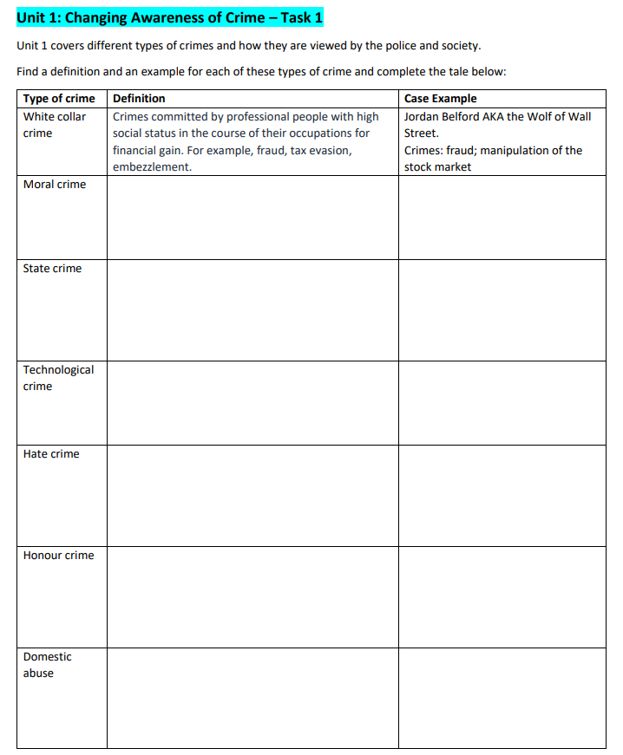

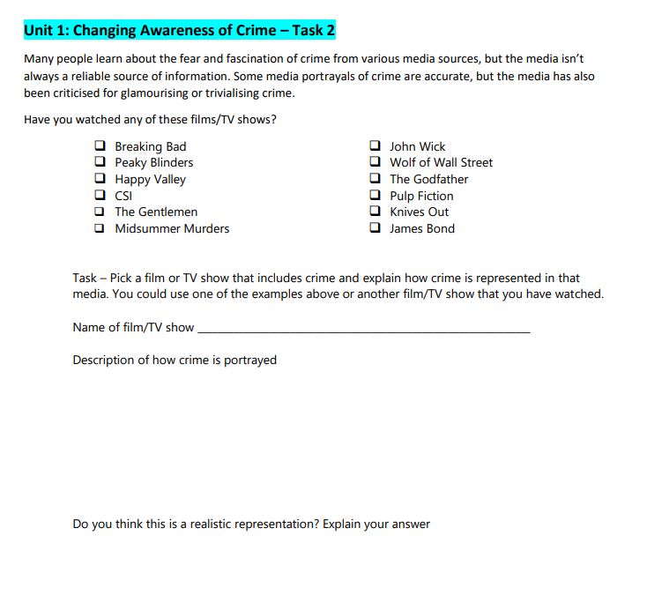



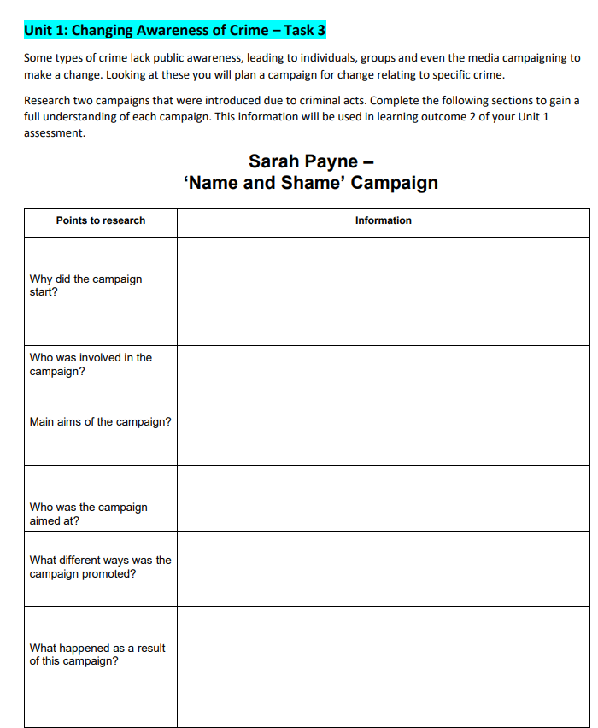

LITERACY TASK

There are many different jobs within the criminal justice system. For each of the following job roles prepare a case file. This should include a detailed description of what the job entails, qualification routes, salaries. You should also present some evaluation of the job. How do they assist in catching/punishing/rehabilitating offenders? In what ways are they limited (by funding, availability, expertise). You will need to do some research for this and include some good quality description and evaluation.

Police officer:

Response Officer

Crime Scene Investigator

Pathologist

Probation Officer

Useful reading/watching

Websites:

https://www.crimeandjustice.org.uk/ http://www.bbc.co.uk/ethics/honourcrimes/crimesofhonour_1.shtml https://www.gov.uk/government/organisations/hm-prison-service https://www.met.police.uk/ http://www.nationalarchives.gov.uk/education/candp/

Films:

The Godfather

Goodfellas

Shawshank Redemption

The Green Mile

The Departed

Books:

Shames – The honour killing that shook Britain – Sarbjit Kaur Athwal

Corporate Crime – Peter Yeager

Domestic Violence and Criminal Justice – Nicola Grove