# Summer Work – Transition from Year 11 to Year 12

A Level Subject: Art

Teacher name and Contact Email: S.Boyle s.boyle@fakenhamacademy.org

Required textbook: n/a

Useful sources:

Pinterest, Google,

Tate website [www.tate.org.uk](https://www.tate.org.uk/)

local galleries- Norwich Castle [www.norwichcastle.norfolk.gov.uk](https://www.norwichcastle.norfolk.gov.uk/)

Sainsbury Centre Norwich [www.sainsburycentre.ac.uk](https://www.sainsburycentre.ac.uk/)

Student Art Guide [www.studentartguide.com](https://www.studentartguide.com/)

Art Today [www.art2day.co.uk](https://www.art2day.co.uk/)

Adrian Hill Gallery, Holt [www.adrianhillfineart.com](https://www.adrianhillfineart.com/)

Castle Fine Art, Norwich [www.castlefineart.com/uk/galleries/norwich](https://www.castlefineart.com/uk/galleries/norwich)

Equipment List:

Drawing pencils – B – 6B

Paint brushes

Water colours

Colouring pencils

Black pen, eraser, pencil sharpener, glue stick, scissors

# **Tasks**

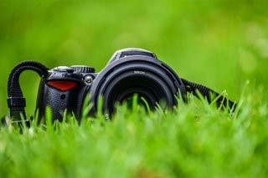 1. Take photos of items relating to the theme of **Natural Forms**. At least 20 photos, try to use a range of locations and look closely for texture, colour and form.

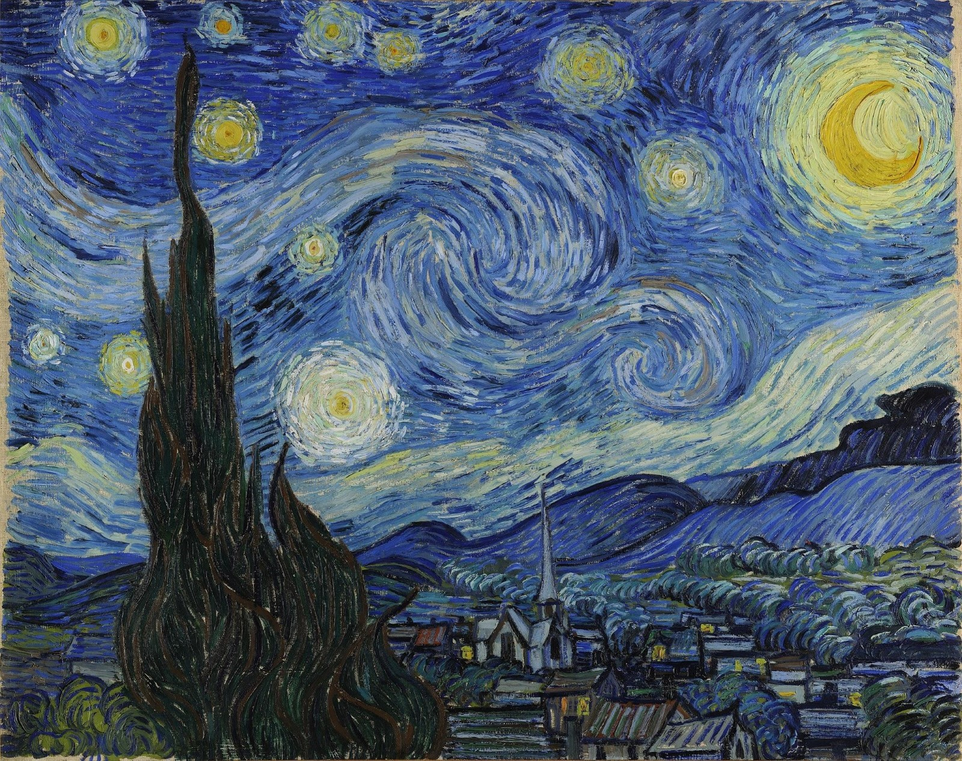2. Research 2 artists that relate to the theme **Natural Forms**, at least 1 Word document per artist. Include images of their work and information about how they created their work and why. We will print these at college and use in September.

3. Using your photographs, complete 1 x pencil tone study and 1 x colour study. You may use your own choice of materials to complete this task.

4. Extension task: go to a gallery or exhibition, take photos, collect postcards! There are lots locally, Norwich and Holt have some great ones!

# Tasks