16-19 Bursary Fund
Financial Support Policy

Contents
1. Introduction 2
2. Administration 2
3. Establishing Eligibility 2-3
4. Claiming the 16-19 Bursary 4
5. Applying for the Discretionary Bursary and Bursary for Vulnerable Groups 4-5
6. Awarding of the Bursary 5-6
7. Allocation of bursary 6
8. Changes in circumstances and revocation of support 6
9. Appendices (Checklist, miniguide, application, self-certification) 7-12

Introduction
  - The 16-19 Bursary comprises two elements; the Discretionary Bursary and the Bursary for defined vulnerable groups.
  - The allocation of funds for the Discretionary Bursary from the Department For Education varies from year to year. As such, awards could vary depending, individual circumstances and established need, on the number of claimants and the total funds received by the Academy.
  - The Bursary for defined vulnerable group is a fixed maximum amount of £1,200 that must be applied for from the Student Bursary Support Service (SBSS) on behalf of a student. This is a means tested bursary, there is no guarantee you will receive this but it will be decided on by need.

Administration
  - Discretionary funds are allocated to the Academy based on census returns and local population information. The nature of funding being lagged may lead to allocated funds not being commensurate with the number of claimants. In order to ensure that students in need are able to claim, and subsequently receive adequate support, the Academy will ensure that a contingency fund is maintained in order to continue to support claimants the following year irrespective of allocation.

Establishing Eligibility
  - It must be established, either by the Academy or via student application, that there is a clear financial need.
    - The eligibility criteria for the Bursary for defined vulnerable groups are set out by the 16-19 Bursary Fund Guidance – as below:
      - The student must be 16 or over but under 19 on 31 August 2026.
      - Students in care n.b. to be eligible students must have been placed in care by the local authority.
      - Students who are care leavers (including those previously in the care of the local authority that has subsequently been placed within a ‘Special Guardianship’ arrangement).
      - Students receiving Income Support, or Universal Credit because they are financially supporting themselves or financially supporting themselves and someone who is dependent on them and living with them such as a child or partner.
      - Students receiving Disability Living Allowance or Personal Independence Payments in their own right as well as Employment and Support Allowance or Universal Credit in their own right.
Receiving 16-19 bursary does not impact any other benefits being received.
Fakenham Sixth Form considers students to be eligible for the Discretionary Bursary if any or all of the following criteria are met:
      - The family is in receipt of Universal Credit.
      - The student is a Young Carer or performs the role of carer for either a parent, close relative or sibling such that paid employment is impractical or unobtainable.
      - Family circumstances including (but not limited to); Parental/Familial disability, Significant mental health conditions, immediate family bereavement.
      - Conditions including physical and mental health conditions or disabilities that limit the ability of the student to access employment or that lead to increased costs for accessing education.
      - Individual circumstances at the discretion of the Bursary Administrators and the Sixth Form and Academy Leadership.
      - Students’ household income is below £50000. (This limit can be increased if a genuine need is seen due to other circumstances such as having a large family).
Unaccompanied Asylum-Seeking Children and other vulnerable Groups not falling into the Statutory or Discretionary Bursary eligibility criteria set out in 3.1.1 and 3.1.2, will be considered eligible for the Discretionary Bursary if any or all of the following criteria are met:
      - Children Seeking Asylum:
        - Unaccompanied Asylum-Seeking Children may receive bursary payments but only after consultation with an appropriate Home Office official.
        - Accompanied Asylum-Seeking Children who have not had applications rejected will only be entitled to in-kind support in the form of Educational Resources and Transport.
        - Other applicable circumstances
        - At the discretion of the Bursary Administrators in cooperation with appropriate bodies (i.e. the Home Office).

Claiming the 16-19 Bursary
  - There is a requirement for a student to have completed an application in order for the Academy to apply to the DFE for the Bursary for defined Vulnerable Groups on behalf of that student in order to ensure that adequate support may be provided.
  - Appropriate evidence of the student meeting one or more of the eligibility criteria for both the Statutory and Discretionary Bursary must have been uploaded to Fakenham Sixth Form Bursary Application 2026/27 – Fill out form or printed and attached to the paper application, by 1st October 2026.
    - For Discretionary Bursaries appropriate evidence is likely to include government documentation for Universal Benefit claimants, those in receipt of another form of legacy benefit, or those registered disabled. For those with medical conditions that affect either the individual or a family member, a doctor’s note or similar would be acceptable. For more complex circumstances it may be necessary for a meeting to take place between students and their parents or guardians, and Sixth Form Leaders. Wherever possible, written evidence must be provided.
    - For Bursaries for defined Vulnerable Groups the evidence must be provided in advance of applications being made to the SBSS, and this evidence will need to be from an official source. In the case of those in care, or care leavers who join from another school, academy or learning provider, this evidence will not automatically be provided by the previous institution and may require the student or their guardian to authorise that institution to disclose information to Fakenham.
    - To establish household income evidence can come from P60’s, self-employment accounts, wage slips, a letter from the DWP, online statements from UC.
    - Copies of evidence provided are kept in accordance with the Academy Data Protection policy and record keeping practices as required by the Department for Education.
    - Applications must still be completed for a student to receive reimbursement for their educational expenses.

Applying for the Discretionary Bursary and Bursary for Vulnerable Groups
  - Applications for both Bursaries are completed using the bursary form Fakenham Sixth Form Bursary Application 2026/27 – Fill out form. If a student's circumstances change as the year goes on, they can apply at a later date.
  - Applications are processed and the eligibility of the claimant is verified by the Bursary Administrators. Upon verification of the claim as valid, Recipients will be notified, and the records updated to reflect they are a Recipient of the 16-19 Bursary.
  - The application requires prospective claimants to detail what the funds will be used to pay for, acceptable intended uses for these funds are:
    - Educational resources – including stationery, equipment, subscriptions, curriculum trips and visits, relevant futures events such as attending University Open Days or applicant days, and other activities expressly related to a students’ next phase of education.
    - To pay for exam resit entries.
    - Transport – this must be transport related to education, i.e. a bus pass / use of the minibus / train tickets or passes / fuel and costs relating specifically to the vehicle that will be used to access education.
    - For food from the Sixth Form canteen.
    - In exceptional circumstances the funding can be used for costs relating that would otherwise result in the student being unable to access education – including but not limited to: accommodation costs if living outside the family/carer home, loss of family income, unavoidable costs associated with job loss, and other circumstances as authorised at the discretion of the Bursary Administrators.
      - These circumstances must be discussed at the earliest possible opportunity with the Bursary Administrators in order to establish how the Academy may best support the student.

Awarding of the Bursary
  - Students will be awarded a bursary amount based on the needs and resources needed for their courses.
  - Students must submit claims for expenditure associated with their education for which they wish to use their bursary. In order for funds to be released to them from their bursary allocation, the following conditions must have been met:
    - Students must have submitted a completed application, supplied the necessary evidence to support that application, and had the application approved via Fakenham Sixth Form Bursary Application 2026/27 – Fill out form
    - Applications must have been received by the deadline (published each year in September).
    - Late applications can be back-dated only as far as 1 term or given appropriate evidence up until the point at which the financial situation that applies to the student occurred/began.
    - Evidence to support the claim must have been supplied and the expenditure aligns with the stipulations set out in 5.4.

To receive bursary students must meet the following criteria:
    - Student attendance is 95% for required sessions – this includes all timetabled lessons, form time, future skills, supervised study, enrichment, intervention sessions, work experience and volunteering - where attendance is below 95%, the absences meet the following conditions:
6.3.1.1. Absences have been appropriately evidenced with parental phone calls to the absence line (for all absences), appointment cards (for all medical and non-medical appointments), Doctor’s notes provided for absences that are for more than five consecutive term days or ongoing absences, and these absences are agreed by the attendance officer or Head of Sixth Form as approved medical (M) or illness (I).
6.3.1.2 Leaves of absence have been authorised using the normal academy procedure and marked accordingly.
  - Demonstrating agreed standards of behaviour by following Fakenham Sixth Form behaviour code.
  - Late applications will be considered for students in any of the circumstances given in 3. (Establishing Eligibility).

Allocation of Bursary.
If you have been awarded bursary funding, you will receive the money in-kind as and when this is possible. This means that Fakenham Sixth Form will buy your needed resources therefor no personal money will need to be spent. In the case of the bursary or defined vulnerable groups, this money will be sent by BACS to the student's bank account on an agreed programme throughout their studies.

Changes in circumstances and revocation of support
  - Bursary payments will continue to be made while a student remains eligible. It is the duty of the Recipient and the Parents/Guardians to inform the Academy of changes in circumstances that may mean the student is no longer eligible.
  - In the event that a student is found to have claimed the Discretionary or Bursary for Vulnerable Groups fraudulently, all monies must be repaid.
  - The purpose of the 16-19 Bursary is to enable students who suffer some financial disadvantage to access post-16 education and the associated benefits and opportunities. If Bursary funds are being used for purposes other than those set out in 5.4, funds may be recalled, or subsequent payments withheld.

Requesting resources and reimbursement
- For a student to request resources and/or a reimbursement they must complete the following form when they need items Fakenham Sixth Form 16-19 Bursary Claim & Reimbursement Form 2026-2027 – Fill out form
- If we are unable to pay for resources in-kind and in the rare occasion that a student needs to claim reimbursement, we must confirm the students bank details to ensure they are the students account and to reduce the risk of fraud Fakenham Sixth Form Bank Detail Confirmation 2026-2027 – Fill out form

Appendices
Appendix 1: DFE Checklist

Area of eligibility or process | Item | Completed?
Eligibility: All Bursaries | Student is aged 16–18 on 31 August of the academic year OR is 19+ and eligible as a continuer or has an education, health and care plan (EHCP).
Eligibility: All Bursaries | Student is enrolled on eligible publicly funded provision.
Eligibility: All Bursaries | Student meets the residency criteria for post-16 provision.
Eligibility: All Bursaries | Eligibility evidence has been seen and copies retained.
Bursary for defined vulnerable groups | Student falls within one of the defined vulnerable groups for example, in receipt of the specified benefits in their own right or in care/care leaver.
Bursary for defined vulnerable groups | Financial needs assessment carried out to confirm financial need and actual costs they have. No student should automatically receive £1,200.
Bursary for defined vulnerable groups | Appropriate evidence seen and copies retained to confirm student’s eligibility, including the letter to support in care.
Bursary for defined vulnerable groups | Funding reflects actual participation costs.
Discretionary bursary | Student meets institution’s bursary criteria.
Discretionary bursary | Evidence of income and overall eligibility obtained, and copies retained.
Discretionary bursary | Assessment of student’s actual financial needs carried out. Block, blanket or flat rate payments are not permitted – the financial support from bursary funds should reflect the actual costs the student has.
Nature of Support Awarded | Support is for essential participation costs only.
Nature of Support Awarded | Support excludes living costs, pastoral, learning support and teaching (that a provider is already funded to deliver), flat rate payments and non-essential activities.
Nature of Support Awarded | Support provided in kind where appropriate (bus pass, meal vouchers, books or equipment purchased on student’s behalf).
Nature of Support Awarded | Receipts or procurement evidence must be retained.
Nature of Support Awarded | Funding used in conjunction with other streams must be according to the guidance.
Attendance, Behaviour and Progress (if applicable) | Any conditions you have set are clearly defined, reasonable, and proportionate.
Attendance, Behaviour and Progress (if applicable) | Any conditions you have set are included in the funding letter.
Attendance, Behaviour and Progress (if applicable) | Monitoring process to support the conditions in place.
Attendance, Behaviour and Progress (if applicable) | Evidence retained if support is suspended or withdrawn because conditions have not been met.
Funding Letter | Funding letter confirms support, conditions, and review points.
Funding Letter | Funding letter issued and retained.

Appendix 2: Bursary Mini Guide
What is the 16-19 Bursary?
The Government has set aside some money for schools, colleges, training providers and local authorities to allocate to young people who need financial support to stay on in further education or training. This is called the 16-19 Bursary Fund. Receiving a 16-19 bursary will not impact any other benefits you receive.
Who is Eligible?
You must:
- be at least 16 and under 19 on 31 August 2026
- study at a publicly funded school or college, or be on an unpaid training course
- meet the residency requirements - your school or college can check this
There are two types of bursaries, Bursaries for defined vulnerable students and discretionary bursaries.

Eligibility for Bursary for Vulnerable students
- Students in care n.b. to be eligible students must have been placed in care by the local authority.
- Students who are care leavers (including those previously in the care of the local authority that has subsequently been placed within a ‘Special Guardianship’ arrangement).
- Students receiving Income Support, or Universal Credit because they are financially supporting themselves or financially supporting themselves and someone who is dependent on them and living with them such as a child or partner.
- Students receiving Disability Living Allowance or Personal Independence Payments in their own right as well as Employment and Support Allowance or Universal Credit in their own right.

Eligibility for Discretionary Bursary

Fakenham Sixth Form considers students to be eligible for the Discretionary Bursary if any or all of the following criteria are met:

The family is in receipt of Universal Credit.

The student is a Young Carer or performs the role of carer for either a parent, close relative or sibling such that paid employment is impractical or unobtainable.
- Family circumstances including (but not limited to); a parent/s or family member with a disability, Significant mental health conditions, immediate family bereavement.
- Conditions including physical and mental health conditions or disabilities that limit the ability of the student to access employment or that lead to increased costs for accessing education.
- Individual circumstances at the discretion of the Bursary Administrators and the Sixth Form and Academy Leadership.
- Children Seeking Asylum
- Have a household income of under £50000
What can the bursary funds be used for?
- Educational resources – including stationery, equipment, subscriptions, curriculum trips and visits, relevant future events such as attending University Open Days or applicant days, and other activities expressly related to a students’ next phase of education.
- Transport – this must be transport related to education, i.e. a bus pass.
How do I apply?
- Applications for both Bursaries must be completed using the bursary form by 1st October 2026. Fakenham Sixth Form Bursary Application 2026/27 – Fill out form
- Applications must include evidence of eligibility (see the list on the form), and these must be uploaded to the application.
- Upon verification of the claim as valid, Recipients will be notified, and the records updated to reflect they are a Recipient of the 16-19 Bursary.
- Fakenham Sixth Form will by the resources in-kind.
- Students must have attendance of at least 95% for required sessions – this includes lessons (all subjects including Extended Project), form time, tutorial, supervised study, intervention sessions, work experience and volunteering to receive the bursary.
- Students must demonstrate agreed standards of behaviour by following Fakenham Sixth Form behaviour code.
ALL INFORMATION INCLUDED ON YOUR APPLICATION WILL BE KEPT CONFIDENTIAL.
a

Appendix 3: Application Form & other forms
Application form
Fakenham Sixth Form Bursary Application 2026/27 – Fill out form
Claim form
Fakenham Sixth Form 16-19 Bursary Claim & Reimbursement Form 2026-2027 – Fill out form
Bank confirmation
Fakenham Sixth Form Bank Detail Confirmation 2026-2027 – Fill out form

Appendix 4: Poster

Appendix 5: Year 13 Circumstances agreement.
In order to continue to receive bursary funding, you must certify to state whether your financial circumstances have changed since your bursary application in Year 12. You must complete this form and hand back to Mrs Marshall-Smith by 1st October 2026.

Student Name: ____________________________________________________
Reg group: ______________________________________________________

Have your financial circumstances changed since you applied for bursary in Year 12? Tick the appropriate box.
- Yes (please explain in the next question)
- No
If yes, what changes have there been?
__________________________________________________________________________________________________________________________________________________________________________________________________________________
I (insert name) _______________________certify that my statement that my financial circumstances have/have not changed are true and accurate. I understand that if this statement is found to fraudulent, I will be responsible for returning the funds to Fakenham Sixth Form.
Signed: ____________________________________ Date: _______________

Once you have completed this form, please indicate what resources you need this year, on the next page.

Which resources will you need this year?
(You will need to return resources at the end of the course, where possible.)
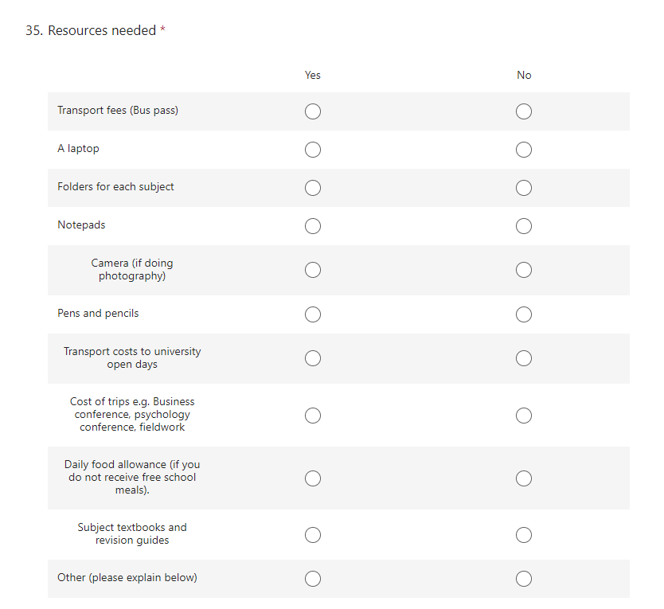Signed: _________________________________________________ Date: ____________________

Appendix 6: Example Letter to Award Define Vulnerable Groups Bursary

Bursary for Defined Vulnerable Groups.
Dear ___________,

I am pleased to confirm that you have been awarded financial support from the DFE 16-19 bursary fund. You are entitled to receive a Bursary for Defined Vulnerable Groups. Based on the evidence you have submitted you will receive a bursary fund of________________________________. This will be paid in eight installments _________ per month directly into your bank account, over the next eight months.
Please ensure that you have supplied your details to our finance team via the bank confirmation form Fakenham Sixth Form Bank Detail Confirmation 2026-2027 – Fill out form so that the money can be paid to you as soon as possible.
Now that you have been awarded this ‘vulnerable groups’ bursary, you cannot apply for any further funding outside this amount.
Any bursary payments are paid on condition that you continue to regularly attend Fakenham Sixth Form. If you stop attending Fakenham Sixth Form, the payments will be stopped.
Yours sincerely,

Appendix 7: Letter to Award Discretionary Bursary

Discretionary Bursary.

Dear ___________,
I am pleased to confirm that you have been awarded financial support from the DFE 16-19 bursary fund. You are entitled to receive a discretionary bursary. Based on the evidence you have submitted you will receive a bursary fund of________________________________. This fund will be spent on resources that we will purchase for you once you request what you need on this form Fakenham Sixth Form 16-19 Bursary Claim & Reimbursement Form 2026-2027 – Fill out form. If you find you need more resources later in the year, please let us know so we can review your bursary amount.
The awarding of the bursary and allocation of resources is dependent on you having 95% attendance and you demonstrating agreed standards of behaviour by following Fakenham Sixth Form behaviour code.
Fakenham Sixth Form can revoke your bursary allocation if you do not meet this requirement.
Resources bought from bursary funding, such as laptops and cameras, must be returned at the end of your course.

Yours sincerely,

16 to 19 Bursary Fund guide 2024 to 2025 academic year - GOV.UK (www.gov.uk)

