**BTEC Level 3 Sport National Extended Certificate**

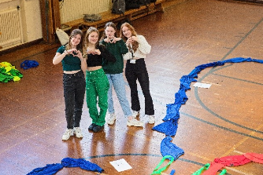**What will I need to study this course?**

You should be interested in applied learning and aiming for higher education and future employment in the sport sector. This qualification is equivalent to one A Level and is designed for a full two-year program alongside other Level 3 qualifications.

**What will I study?**

* Anatomy and Physiology
* Fitness Training and Programming for Health, Sport and Well-being
* Professional Development in the Sports Industry
* Application of Fitness Testing

**How is the course assessed?**

* Anatomy and Physiology – May Year 12 – 1hr 30mins
* Fitness Training and Programming for Health, Sport and Well-being – January Year 13 – 2hrs 30mins
* Professional Development in the Sports Industry – Coursework Year 12
* Application of Fitness Testing – Coursework Year 13

**Where next?**

This qualification is equivalent to an A Level and recognized by higher education providers.

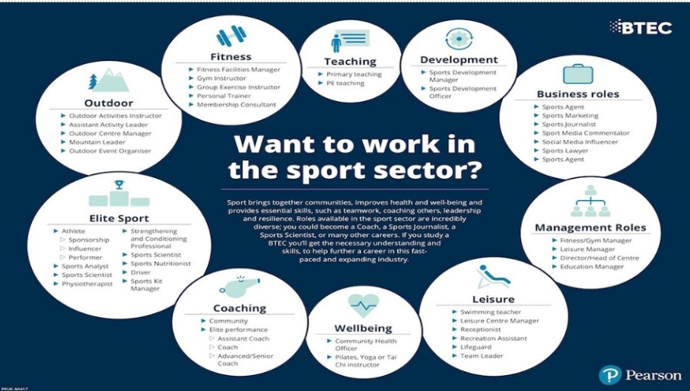[What can I do with a sports coaching degree? | Prospects.ac.uk](https://www.prospects.ac.uk/careers-advice/what-can-i-do-with-my-degree/sports-coaching)

*Exam Board: Edexcel*

*QAN Code: 601/7218/6*