**Sport BTEC Level 3 National Diploma**

**What will I need to study this course?**

You should be interested in applied learning and aiming for higher education and future   
employment in the sport sector. This qualification is equivalent to two A Levels and designed for a full two-year program alongside other Level 3 qualifications.

**What will I study?**

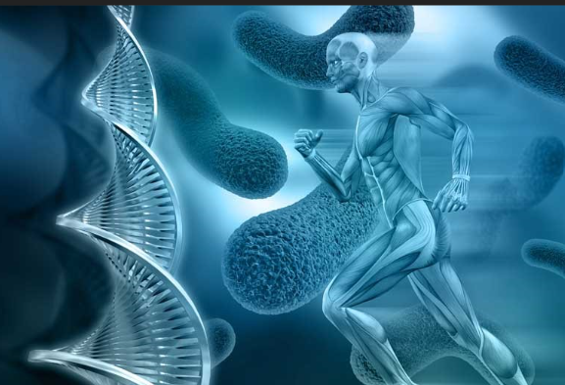You will complete six mandatory units:   
• Anatomy and Physiology   
• Fitness Training and Programming for Health, Sport and Well-being   
• Professional Development in the Sports Industry   
• Sports Leadership   
• Investigating Business in Sport and the Active Leisure Industry   
• Skill Acquisition in Sport

You'll also study three optional units from:   
• Application of Fitness Testing   
• Sports Psychology   
• Practical Sports Performance   
• Coaching for Performance   
• Sport Injury Management   
• Rules, Regulations and Officiating in Sport.

**How is the course assessed?**

* Anatomy and Physiology – May Year 12 – 1hr 30mins
* Fitness Training and Programming for Health, Sport and Well-being – January Year 13 – 2hrs 30mins
* Professional Development in the Sports Industry – Coursework Year 12
* Sports Leadership
* Investigating Business in Sport and the Active Leisure Industry – January Year 12 – 3hrs
* Skill Acquisition in Sport – Coursework Year 13
* Application of Fitness Testing – Coursework Year 13
* Sport Injury Management – Coursework Year 12
* Rules, Regulations and Officiating in Sport – Coursework Year 12

**Where next?**

This qualification is equivalent to two A Levels and recognized by higher education providers.

[What can I do with a sports coaching degree? | Prospects.ac.uk](https://www.prospects.ac.uk/careers-advice/what-can-i-do-with-my-degree/sports-coaching)

*Exam Board: Edexcel*

*QAN Code: 603/0460/1*