**A Level Photography**

**What will I need to study this course?**

This course is great for students who are creative and imaginative. You don't need specific subjects, but you should be interested in Photography and have a creative mind. Having a GCSE in Photography or Art could help but it's not necessary.

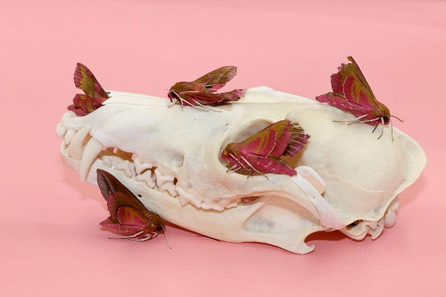

**What will I study?**

You'll learn different approaches to photography,   
working with signs, symbols, and images. You'll understand artistic styles like portrait, landscape, and movement. The course covers:

* The role of photography in areas like graphics, fashion, and documentary.
* Techniques like controlling shutter speed and using aperture.
* Using different lighting, pictorial space, scale, and structure.
* 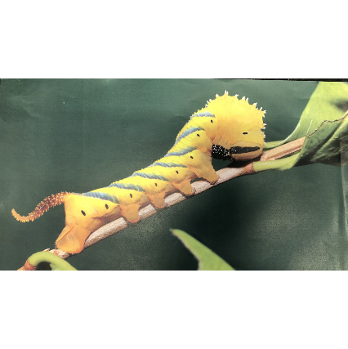Editing images using digital tools and software.

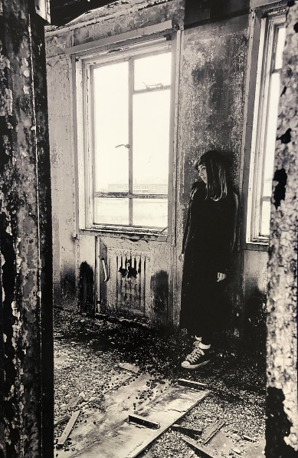

**How is the course assessed?**

The assessment has two parts:

**Component 1: Personal Investigation**

* In the first year, you'll try out techniques, develop skills, and create personal projects.
* You'll research photographers and write about their work.

**Component 2: Externally Set Assignment (ESA)**

* In the second year, you'll build a coursework portfolio.
* You'll write a personal study of up to 3000 words about your work in a historical or contemporary context.

The ESA, worth 40% of your A Level, involves responding to a theme set by AQA and creating a project over 15 hours.

**Where next?**

After this course, you can go into jobs, apprenticeships, or higher education in Photography or other fields. You'll gain skills in visual communication, digital editing, critical thinking, and creative problem-solving, useful for many careers.

[What can I do with a photography degree? | Prospects.ac.uk](https://www.prospects.ac.uk/careers-advice/what-can-i-do-with-my-degree/photography) .

*Exam Board: AQA*

*QAN Code: 601/4456/7*