**A Level History**

**What will I need to study this course?**

GCSE History grade 5 or higher plus English Language / Literature grade 5 or higher is desired but all applications are considered on an individual basis. Students who have not previously studied GCSE History are welcome providing their English meets requirements.

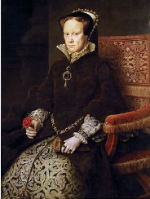**What will I study?**

History helps us understand who we are, where we came from and how the world is the way it is today. History is about people and if people interest you then so will history.

Unit 1 England 1547-1603: The Later Tudors – 25% of A level   
Unit 2 Russia 1894 – 1941 – 15% of A level   
Unit 3 Popular culture and the witch craze of the 16th and 17th centuries – 40% of A level   
Unit 4 Non examined assessment on The Holocaust (coursework) - 20% of A level   
  

We will study the interesting figures of the late Tudor reign; Edward VI the boy king, ‘Bloody’ Mary I and Elizabeth I, ‘Virgin Queen’. We will focus on the fascinating events between 1547 and 1603 including rebellions, religious turmoil, poverty, exploration and economy. In particular, we examine how the monarchs dealt with the challenges of being a child or a woman ruler in the 16th century in an age when a male King was the norm.

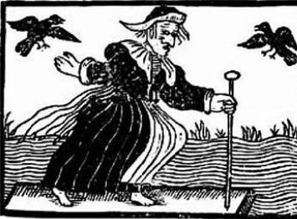

To compliment this unit, you will also study popular culture and the Witchcraze at this time and what we learn about society at this time from their treatment of witches. You will look at elements of popular culture such as festivals, feast days and punishment of wrong-doers, and also study in depth case studies of the witch trials in England, Germany and Salem in the USA.

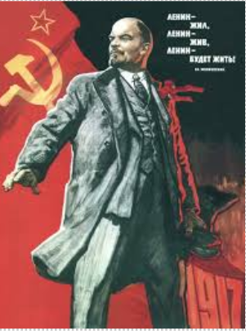

 In contrast, Russia deals with revolution, communism and dictatorship in much more recent times as you study the downfall of the final Russian Tsar, the rise of Lenin and subsequently Stalin and the dictatorship he created.

Finally, there is a coursework unit on the Holocaust which offers a chance to complete a rigorous piece of work to university level.   
    
You will continue to work analysing primary sources, evaluating interpretations and practice extended writing in the form of essays.  

**How is the course assessed?**

All exams will be taken at the end of the two-year course. Non-examined assessment (coursework) will be completed by February half term in year 13.

Unit 1 England 1547-1603: The Later Tudors – 1 hour 30-minute exam   
Unit 2 Russia 1894 – 1941 – 1 hour exam   
Unit 3 Popular culture and the witch craze of the 16th and 17th centuries – 2 hour 30 minute exam   
Unit 4 coursework, non-exam assessment

**Where next?**

History combines well with all other subjects, especially English, Sociology, Philosophy, Geography and Politics. It provides an excellent foundation for careers such as Law, Teaching, Local Government and Civil Service, Politics and Journalism to name but a few! History teaches you to analyse information critically and communicate effectively.

[What can I do with a history degree? | Prospects.ac.uk](https://www.prospects.ac.uk/careers-advice/what-can-i-do-with-my-degree/history)

*Exam Board: OCR*

*QAN Code: 601/4701/5*