**A Level Further Maths**

**What will I need to study this course?**

You need to have achieved at least a grade 6 in GCSE Mathematics and be studying A Level Mathematics.

**What will I study?**

This course is for students who really enjoy maths and want to learn more. It covers many interesting and challenging topics.

 Pure Mathematics: Two-thirds of the course focuses on pure maths, including:

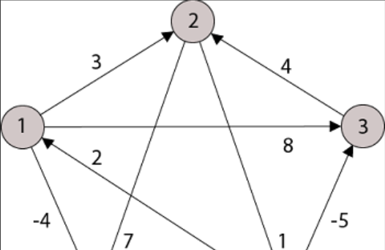  - Imaginary numbers and complex numbers (like *i)*

  - Matrices for transformations and solving equations

  - Polar coordinates, hyperbolic functions, and differential equations

  Applied Mathematics: One-third of the course covers applied maths. Students can choose two topics from statistics, mechanics, or discrete maths. Topics usually include:

  - Mechanics: How forces and motion work

  - Statistics: Collecting and analysing data

  - Discrete Maths: Studying networks, graphs, and algorithms (like how a sat nav finds the best route)

**How is the course assessed?**

The entire course is assessed through exams. At the end of Year 13, there will be three two-hour exams.

**Where next?**

Further Mathematics is highly respected by universities, especially for students interested in science or engineering degrees. If you plan to study mathematics, physics, or engineering at university, this course introduces many concepts you'll encounter there and will support your studies significantly.

[What can I do with a mathematics degree? | Prospects.ac.uk](https://www.prospects.ac.uk/careers-advice/what-can-i-do-with-my-degree/mathematics)

*Exam Board: AQA*

*QAN Code: 8365*