**A Level Fine Art**

**What will I need to study this course?**

This course is perfect for students who love being creative and imaginative. You should have a grade 5 or higher in GCSE Art and Design, or you can show your art portfolio to join.

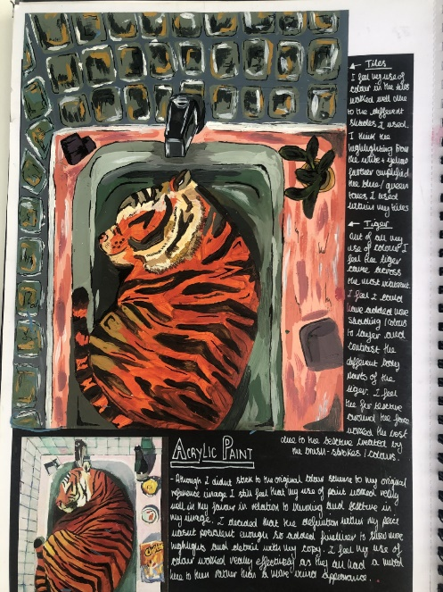

**What will I study?**

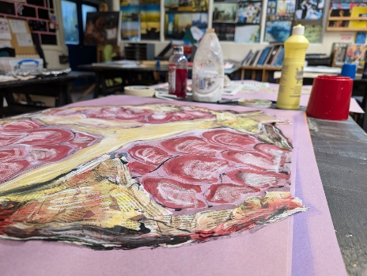You will work with different materials and techniques to try out new ideas and find your own style. You will also learn about other artists and designers by looking at their work and visiting galleries. You'll practice working on your own and use other sources of information for your projects.

**How is the course assessed?**

The course is divided into two parts:

1. Personal Investigation (Component 1):

* In the first year, you'll explore various materials and skills, record your ideas, and create your own artwork. You'll also study different artists and write about their work.
* In the second year, you'll continue to build a portfolio of your artwork and write a 3000-word essay about your work and its place in art history or current trends.

This part counts for 60% of your A Level.

2. Externally Set Assignment (Component 2):

* In the second year, you will also complete an exam project based on a theme given by the exam board AQA in February. You'll do preparatory work   
  and then have 15 hours to create your final piece(s).

This part is worth 40% of your A Level.

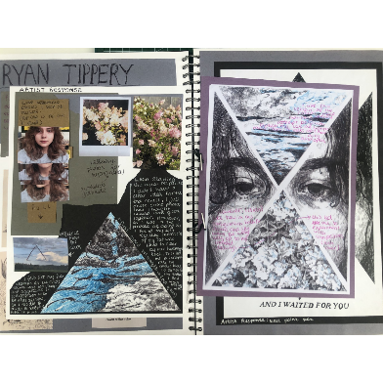**Where next?**

After this course, you can go into jobs, apprenticeships, or higher education courses related to art or even in different fields.

[What can I do with a fine art degree? | Prospects.ac.uk](https://www.prospects.ac.uk/careers-advice/what-can-i-do-with-my-degree/fine-art)

*Exam Board: AQA*

*QAN Code: 601/4456/7*