**A Level Film Studies**

**What will I need to study this course?**

You don’t need to have studied Film or Media Studies at GCSE, but you should enjoy watching films and know about British, American, and World Cinema. You should have a Level 4 or above in GCSE English.

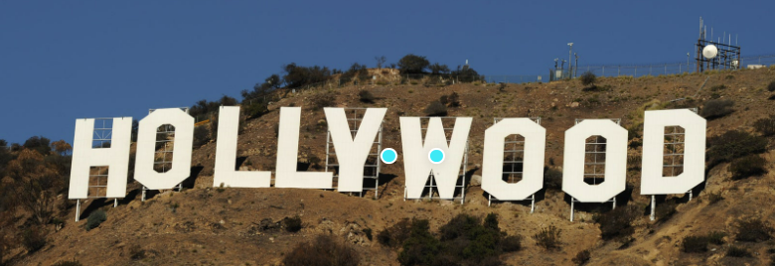**What will I study?**

Component 1: American and British Film

  You will study six full-length films from different areas:

  - Classical Hollywood

  - Hollywood since the 1960s

  - Contemporary American Independent Film

  - British Film

**Component 2: Varieties of Film**

  You’ll learn about five full-length films and a set of short films. Topics include:

  - Silent Cinema

  - Experimental Film

  - Documentary Film

  - Global Film Movements

**Component 3: Production**

  For your practical coursework, you will create either:

  - A short film (4-5 minutes long)

  - A screenplay for a short film (1600-1800 words) and a storyboard for a key part of that screenplay, photographed digitally.

  You will also write an evaluation (1250-1500 words) of your work.

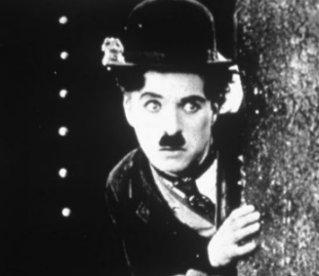

**How is the course assessed?**

Components 1 and 2: You’ll take 3-hour written exams for each, which make up 35% of your final grade each.

Component 3: This is coursework assessed internally and makes up 30% of your overall grade.

**Where next?**

You might choose to study Film or Media courses at university – there are many different ones to choose from. We also provide experiences and opportunities to help you move on to university or find a job.

[What can I do with a degree in film studies? | Prospects.ac.uk](https://www.prospects.ac.uk/careers-advice/what-can-i-do-with-my-degree/film-studies)

*Exam Board: Eduqas*

*QAN Code: 603/1147/2*