**Applied Criminology A Level**

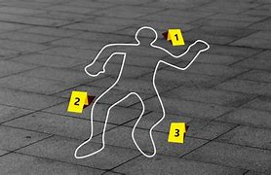**What will I need to study this course?**

To study Criminology, it's helpful to have a good grade in GCSE Science, Maths, and English Language.

**What will I study?**

**In the first year, you'll study:**

* **Unit 1: Changing Awareness of Crime**

This unit will give you an understanding of how crime is presented in the media and how campaigns for change work.

This unit involves an 8-hour controlled assessment that's internally assessed at your school and externally moderated.

* **Unit 2: Criminological Theories**

You will learn about the psychological and sociological explanations of crime.

This unit is assessed through an exam with short answer and extended writing questions, lasting 1 hour 30 minutes.

**In the second year, you'll study:**

* **Unit 3: Crime Scene to Courtroom**

This unit will give you knowledge of the processes involved in convicting criminals.

This unit includes an 8-hour controlled assessment that's internally assessed and externally moderated.

* **Unit 4: Crime and Punishment**

Your final unit will investigate the effectiveness of a range of punishments for criminal behaviours.

This unit is assessed through an exam with short answer and extended writing questions, lasting 1 hour 30 minutes.

**How is the course assessed?**

In both Year 12 and 13 students will be assessed by an eight-hour piece of coursework in the autumn term and then an exam in the summer term.

**Where next?**

Many students go on to study Criminology at university. A Criminology qualification can lead to careers in various fields such as the police force, forensic psychology, social and probation work, or the prison services.

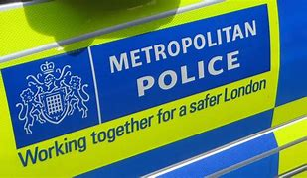[What can I do with a criminology degree? | Prospects.ac.uk](https://www.prospects.ac.uk/careers-advice/what-can-i-do-with-my-degree/criminology)

*Exam Board: Eduqas*

*QAN Code: 601/6248/X*