**A Level Biology**

**What will I need to study this course?**

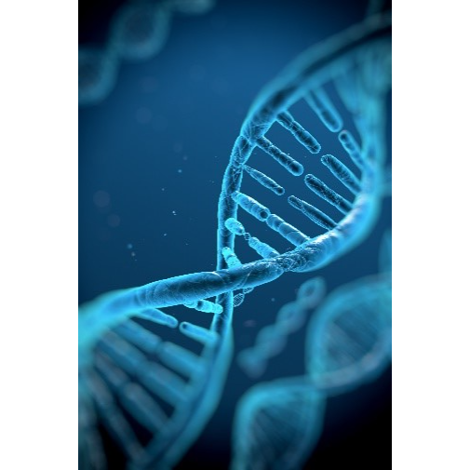Students need to have knowledge of Biology either as a single GCSE Biology subject or as part of a GCSE Combined Science course. Students should have gained at least a grade 5 in GCSE Maths and 6 in Biology or a grade 6-6 in Combined Science.

**What will I study?**

This course focuses on how Biology is used in real life and its effects on people, the economy, and the environment. You'll learn how to solve problems scientifically.

In the first year, you'll study:

1. Biological Molecules

2. Cells

3. How organisms exchange substances with their environment

4. Genetic information, variation, and relationships between organisms

In the second year, you'll study:

1. Energy transfers in and between organisms

2. How organisms respond to changes inside and outside their bodies

3. Genetics, populations, evolution, and ecosystems

4. The control of gene expression

**How is the course assessed?**

There are three exam papers at the end of Year 13. You will have to analyse experimental data and write one essay from a choice of two titles.

**Where next?**

This course can lead to careers in Medicine, Veterinary work, Nursing, Zoology, Marine Biology, Pharmacy, Biochemistry, Psychology, Molecular Biology, Ecology, Biomedical Sciences, and more.

[What can I do with a biology degree? | Prospects.ac.uk](https://www.prospects.ac.uk/careers-advice/what-can-i-do-with-my-degree/biology)

*Exam Board: AQA*

*QAN Code: 601/4625/4*